15.67: There is a node at the post and there must be a node at the clothespin. There could be additional nodes in between. The distance between adjacent nodes is 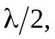 so the distance between any two nodes is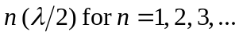
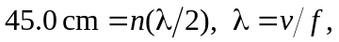 so

